King Fahd University of Petroleum and Minerals
Information and Computer Science Department

ICS 103: Computer Programming in C
Fall Semester 2006-2007 (Term-061)

Major Exam-II

Time:100 minutes Thursday, December 7, 2006

Name:
ID#:

PLEASE CIRCLE YOUR SECTION BELOW:
Section | 01 | 02 | 03 | 04 | 05
Time | 9-9:50am | 8-8:50am | 10-10:50am | 11-11:50am | 1:10-2pm
Note:

- Copying or Discussion will result in zero grade for all the students involved.
- Attempt all questions.

Question # | Maximum Marks | Obtained Marks
1 | 40
2 | 10
3 | 10
4 | 10
5 | 10
6 | 20
Total | 100

Question 1: 40 points (6+6+9+6+8+5)

Program | Output
#include<stdio.h> // 6 points  int main(void){  int x[6],i;  x[0]=1; x[2]=3; x[4]=5;  for (i=5;i>0;i=i-2)  x[i]=x[i-1]+i;  for (i=1;i<6;i=i+2)  printf("%d\t",x[i]);  return 0;  } | 2 6 10
#include<stdio.h> // 6 points  void find(int x[],int y[],int m){  while(m>=0){  y[m]= x[m]*m;  m=m-1;  }  }  int main(void){  int x[3]={7,5,2};  int y[3];  find(x,y,2);  printf("%d\t%d\t%d",y[0],y[1],y[2]);  return 0;  } | 0 5 4
#include<stdio.h> // 9 points  #define size 6  int main() {  int x[size],i;  for (i=0;i<5;i=i+2){  x[i]=i*2;  if(i%2==0)  x[i+1]=x[i]+i+1;  else  x[i]=x[i-1]+3;  }  for (i=0;i<size;i++)  printf("%d ",x[i]);  return 0;  } | 0 1 4 7 8 13
#include <stdio.h> // 6 points  int main() {  int a,b,c=8,*p1,*p2;  p1=&b;  p2=&c;  *p2+=2;  *p1=*p2+3;  p1=&a;  *p1=b+*p2;  printf("a= %d,b= %d,c= %d\n", a,b,c);  return 0;  } | a= 23 b=13 c=10
#include <stdio.h> // 8 points  void f1(int a,int *b);  void f2(int x[]);  int main() {  int b[]={1,2,3};  int a[]={7,8,9};  f1(b[1],&b[2]);  f2(a);  printf("%d %d\n",b[1],b[2]);  printf("%d %d %d\n",a[0],a[1],a[2]);  return 0;  }  void f1(int a,int *b) {  a=a+3;  *b=a;  }  void f2(int x[]) {  int i;  for (i=0;i<3;i++)  x[i]=x[i]+2*i;  } | 2 5  7 10 13
#include <stdio.h> // 5 points  int fun(int n) {  if(n==0)  return n;  else if(n%2==0){  printf("%d\n",n);  return 1+fun(n/2);  }  else  return fun(n/2);  }  int main() {  printf("%d",fun(18));  return 0;  } | 18  4  2  3

Question 2: (10 points)
Write a function with name pattern. It receives an integer n as parameter and prints on the screen numbers from 1 to n with a specific pattern using nested loops. The following are patterns of sample calls. Don’t write the main function

Call | pattern(1) | pattern(3) | pattern(5)
Output | 1 | 1  22  333 | 1  22  333  4444  55555

#include <stdio.h>
void pattern(int n) {
int i,j;
for (i=1;i<=n;i++) {
for (j=1;j<=i;j++) {
printf("%d",i);
}
printf("\n");
}
}

Question 3 (10 points):
Write a function that receives x (double) and n(positive integer) and computes and returns x^{n} using iterations. No main function

double power(double x,int n) {
int i;
double product=1.0;
for (i=1;i<=n;i++) {
product=product*x;
}
return product;
}

Question 4 (10 points)
Write a function that receives the values of polar coordinates r and theta (in degrees). The function returns the corresponding rectangular coordinates given by:
x=r sin(theta)
y=r cos(theta)
declare pi as a constant inside the function with a value of 3.14159. No main function

#include <math.h>
void polrect(double r,double theta, double *x, double *y) {
const double PI=3.14159;
theta=theta/180*PI;
*x=r*cos(theta);
*y=r*sin(theta);
}

Question 5 (10 points)
Write a recursive function to perform multiplication of two positive integers (m and n) using addition.
i.e. m*n=m+m+m+…+m (ntimes)

int recmult(int m,int n) {
if(n==1)
return m;
else
return m+recmult(m,n-1);
}

Question 6 (20 points):
Write a c program that creates a 1-D array of 10 double elements. Then it reads the 10 real values from a file “input.txt” and stores them in the array. Your program should find the average. It then counts the number of values below average, and write them into another file “below.txt” one value per line. After that it writes their count in the same file. A sample execution of your program for the following “input.txt” file

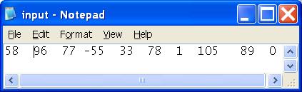
Will show
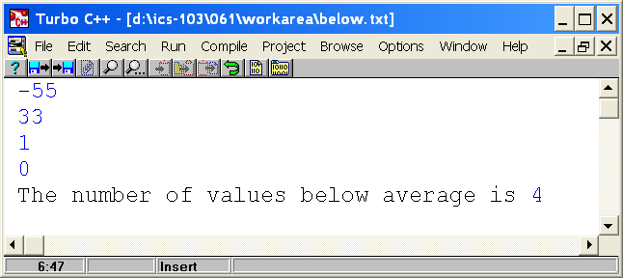

#include <stdio.h>
#define SIZE 10
int main() {
int b[SIZE];
int sum=0,i,count=0;
double average;
FILE *in,*out;
in=fopen("input.txt","r");
for(i=0;i<SIZE;i++){
fscanf(in,"%d",&b[i]);
sum=sum+b[i];
}
average=sum/SIZE;
out=fopen("below.txt","w");
for (i=0;i<SIZE;i++){
if(b[i]<average){
fprintf(out,"%d\n",b[i]);
count++;
}
}
fprintf(out,"The number of values below average is %d\n",count);
fclose(in);
fclose(out);
return 0;}

